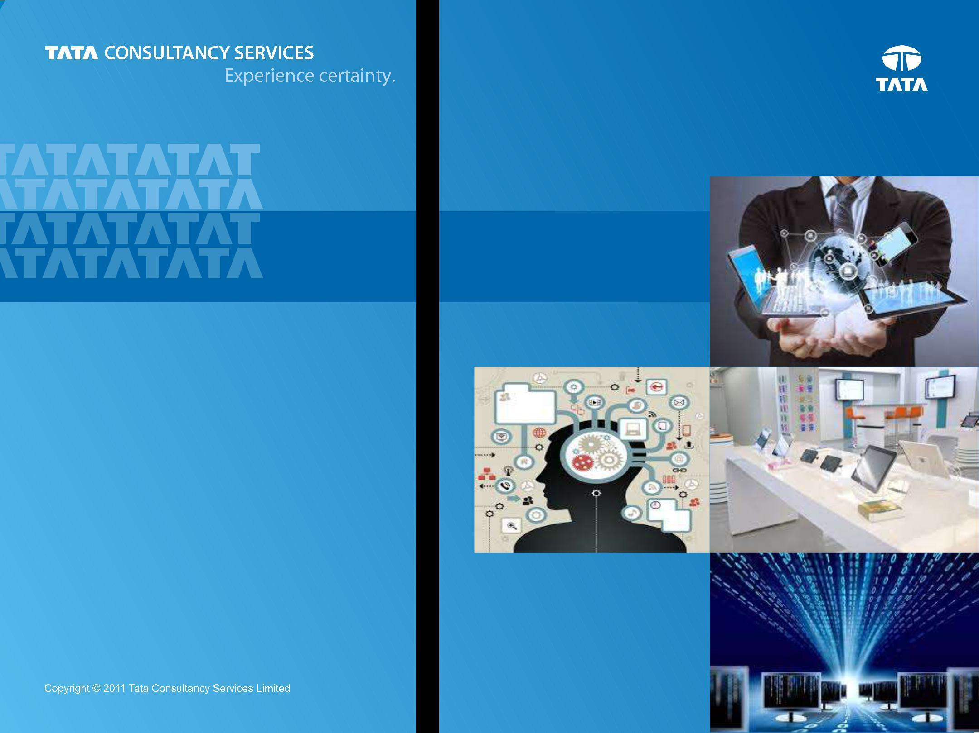

***Bank’s view of itself***

***Customer’s View of Bank***

**Digital Banking**

***Chapter 3 : Banking Digitally***

**Prepared : October, 2014**

1

**Content**



**Introduction**



**Customer**



**Banking Digitally**



**Channel Transformation**



**Effects on Retail LoBs**



2



**Digital Disruption on Financial Services**

***Banks are in risk of becoming an infrastructure provider while service layers like Payments, Advice, Currency Exchange, Loans are provided by somebody else***

| **Regulations** |  | **Consumer Readiness** |  | **New Technologies** |
| --- | --- | --- | --- | --- |
|  |  | APIs enable disruptors to add |
| Absence of capital |  | Digital channels & media |  |
|  |  | capabilities from 3rd parties |
| requirements for digital |  | usage from point of |  |
|  |  | quickly and easily, bringing a |
| entities; Current Account |  | inspiration to point of action; |  |
|  |  | level of integration with |
| switch service from Payments |  | Lower propensity to come to |  |
|  |  | partners that didn’t exist just |
| Council (UK) |  | bank for banking |  |
|  |  | a few years ago |
|  |  |  |  |
|  |  |  |  |  |

| **Business Adjacency** |  |  |  | **All about Ecosystem** |
| --- | --- | --- | --- | --- |
| Digital PFM providing tailored |  | **Functions Decoupled** |  |
|  |  | @POS offers enabled by |
| advice (beyond transaction |  | MNOs into prepaid, Digital |  |
|  |  | providers of Cards, Analytics, |
| aggregation); Financial |  | Payment players (PayPal, |  |
|  |  | Retailer, MNO, TSM, Secure |
| Inclusion solutions thru |  | Square) into lending |  |
|  |  | Payment option / Wallet |
| Mobility from Utilities |  |  |  |
|  |  |  |  |
|  |  |  |  |  |

***Winners will create their own value ecosystem offering core capabilities and act as orchestrators serving as hub of capabilities***



3



**.. but Banks are not lone victims**

***Telecom industry also sees similar disruptions and hence the need to redefine themselves***



**Large players, limited**

**Heavily Regulated**

**differentiation**



| **New Entrants** | **Relegated to being a** | **Customer Experience** |
| --- | --- | --- |
| Skype taking away | **key; size along does not** |
| **Data Pipe** |
| significant traffic | **cut it** |
|  |



**Heavier share of**

**Low barriers to switch**

**negative customer Deal seeking customers over**

**sentiments**



4



**What’s happening outside BFS ?**

|  | *Experience* | *Digital Parity across* | *Life event* | *Usage Based* |
| --- | --- | --- | --- | --- |
|  |
|  | *Circles (Home,* | *Channels enabling* | *management* | *Insurance with* |
|  | *Auto) with end* | *seamless experience* | *thru NextGen* | *sensors and* |
|  | *to end touch* | *with limited Branch* | *analytics (IBM* | *analytics,* |
|  | *point* | *presence* | *Watson)* | *Location based* |
|  |  |  |  | *emergency alerts* |

| *Store in hand:* | *Store IOT: Videos,* | *Realizing infra* | *Augmented* |
| --- | --- | --- | --- |
| *Customer* | *Footfall heat maps,* | *potential: Digital* | *Reality solutions:* |
| *analytics,* | *comfort / safety* | *Walls to continue* | *Navigation,* |
| *Inventory status -* | *parameters,* | *store leverage* | *Interactive* |
| *more time with* | *Contextual Ads, Call* | *beyond regular* | *Campaign* |
| *customer* | *Helpdesk* | *hours* |  |

| *Personae:* | *Real time Analytics &* | *Stratified View:* | *KPI Driven* |
| --- | --- | --- | --- |
| *Interplay of* | *Offer Management =* | *Presentation +* | *Business* |
| *Subscription,* | *Personae + Context +* | *Commerce &* | *Transformation* |
| *Consumption & Pre assembled actions* | | *Care +* | *Model covering* |
| *Association* |  | *Commercial* | *Customer* |
|  |  | *Convergence* | *Experience and* |
|  |  |  | *Efficiency* |
|  |  |  | 5 |



**Digital Banks : Can we bank on them ?**

***Characteristics = Centered around Mobile + Social Principles embedded + Money management at the core + Partnerships focused to ‘get’ basic services***

***and***

***Models = Subsidiaries + Independent Licensee + Virtual Front end***

| ***Banking Community*** | ***Banking with Friends*** | ***Money Management*** |
| --- | --- | --- |
| To exchange opinions, peer | Seek contributions from | Tracking & Budgeting tools, |
| advice, discuss problems, | friends & family to savings |
| “Safe to Spend” indicators, |
| “suggest” on interest rates, | projects, Pay thru ‘Friends’ |
| financial health overview |
| vote on ideas | list, Digital Piggybank |
|  |



***Partnerships***



Jibun = Bank of Tokyo-

Mitsubishi + KDDI

Fidor + Currency Cloud = forex buy sell, payments, multi currency balances

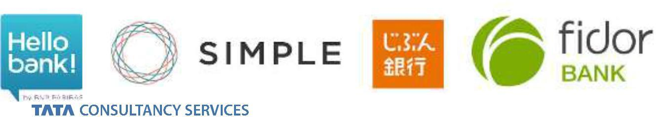

***Miscellaneous***



Frictionless OAO, Affordability trackers at point of purchase, transparent fee structure, P2P Lending / Crowd funding, Free ATM access, Digital Wallet



6



**Money Management ...**

***Digital Money Management (passing data ownership back to customer) = Account Aggregation***

***+ Automatic Spend Categorization + Budgeting + Goal Setting + some more …***



|  |  | PFM Dashboard as 1st | New Data |
| --- | --- | --- | --- |
|  | Familiarity : Not | screen once customer |
| Adoption: providers | Visualization |
| integrated as part of | logs on; then moves |
| have not educated | capabilities |
| on boarding or Home | on to ‘transacting’ |
| customers enough |  |
| Page |  |  |
|  |  |  |
| Personalization : Not | Ease of Use : Not | Advisory & Accessory | Optimized for Mobile |
| Tools pertaining to Life | phones (not just |
| customized to | intuitive enough for |
| Stage | online / tablet) |
| individual needs, no | tracking and managing |
|  |  |
| contextual advice | goals |  |  |
|  |  | Open platforms with APIs for 3rd parties to develop | |
|  |  | Widgets, Apps | |



***… characteristics expected to be simple, ubiquitous, personal, empowering and reassuring thereby deepening customer relationships, garner loyalty of younger customers and counter disruption from Digital Banks.***



7



**… and Gamification**

***Classically Defined as : Insertion of game dynamics and mechanics into non game activities to drive desired behavior***

***Advantages*** ***Watch Outs***



* Cuts across age groups, gender and income levels
* Economic and Effective to engage customers, promote online usage and drive product sales
* Rewards Fatigue
* Experience gaps and ability to engage with new content and themes
* Complexity of online and mobile apps marring gaming experience



***Points, Challenges, Leaderboards, Badges***

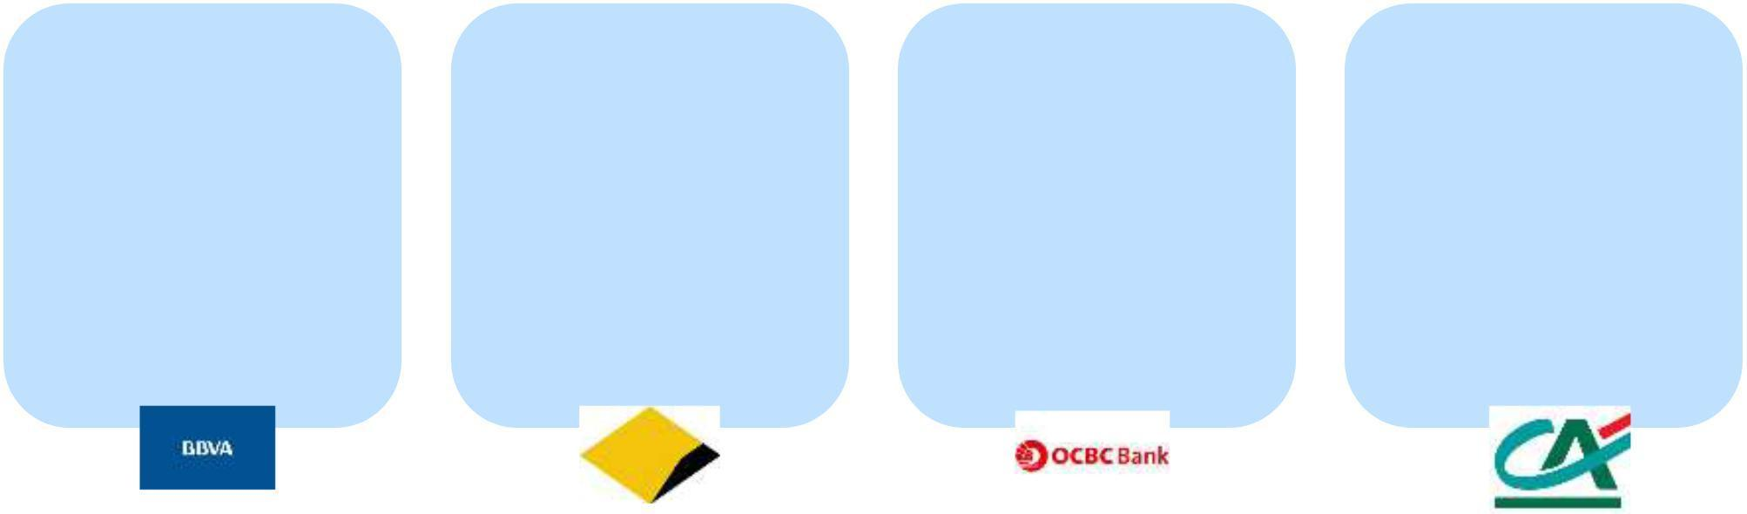

| **Use of Online Banking** | | | **Stimulate Property** | | | **Financial Literacy for** | | | **Awareness on Home** | | |
| --- | --- | --- | --- | --- | --- | --- | --- | --- | --- | --- | --- |
|  | **Services** | | **Investment** | | |  | **Kids** | | **Insurance Offerings** | | |
| Earning points for online | | | Investorville has | | | Mighty Savers program | | | Simulated fights using | | |
| banking transactions, | | | simulation with complex | | | to digitally incentivize | | | video game animation ; | | |
| friends reco, new prod, | | | economic model & | | | savings behavior than | | | suggestions to losers on | | |
| surprise challenges | | | market data, search | | | instant spending | | | home insurance product | | |
| tradable for prizes or | | | based on price & | | | (actions: earn, give, | | |  |  |  |
| raffle entries | | |  | amenities | | spend, save, invest) | | |  |  |  |
|  |  |  |  |  |  |  |  |  |  |  |  |
|  |  |  |  |  |  |  |  |  |  |  |  |
|  |  |  |  |  |  |  |  |  |  |  |  |
|  |  |  |  |  |  |  |  |  |  |  |  |



8



**So .. What should banks do ?**

***“What’s New in iOS8” has so much resonance to key Digital imperatives for Banking & Financial Services***

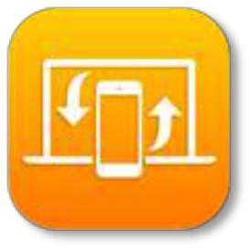

***Tracking and Analyzing***

***‘moments’ in customer life***

***Listening and interacting across diverse channels and modes***

***Making it convenient and usable to do banking anywhere, anytime on any device***



***Collaborating in a fragmented ecosystem serving customer needs at the core***



***House holding and comprehensive Customer 360***

***Enterprise Information Cloud dispensing experience and analytics output at needed points***

***Healthcare and other Life enhancing experiences***

***Experience Continuum across Touch Points***



***Enterprise Search enabling contextual content to all bank users***

***API unleashing potential in Functions and Data***



***Enabling self management capabilities in hands of end customers and internal users***

9



**Bank Imperatives**

***All engines to fire ; just efficiency plank will only float so far as it does not create any competitive differentiation for customers***



**Simplified & Optimized**



**Flexible, Dynamic & Agile**



Multi Country, Multi tenant and possibly multi business platforms



Digitized front end with a lean back office

Ease of adding new featured by atomized service layer for Rules & BPM to orchestrate in different ways



Participation in digital ecosystem by integrating 3rd party services (data feeds, offers, credit reviews, payment engines

Focus on Finance, HR, Logistics and Operations



Analytically driven front office with embedded analytics in processes throughout enabling Personalized context based interaction at any point



Virtualizing the bank’s network with strong data analytics and mobility across the distribution spectrum

***Along with continued Innovation (to proactively stay ahead of the market) and Structural Tweaks (aligned CIO-CMO-CRO, distributed digital talent, central Customer Experience,***

***external talent supplements)***



10



**Next Chapter : 4**



**Introduction**



**Customer**



**Digital Banking**



**Channel Transformation**



**Effects on Retail LoBs**



11



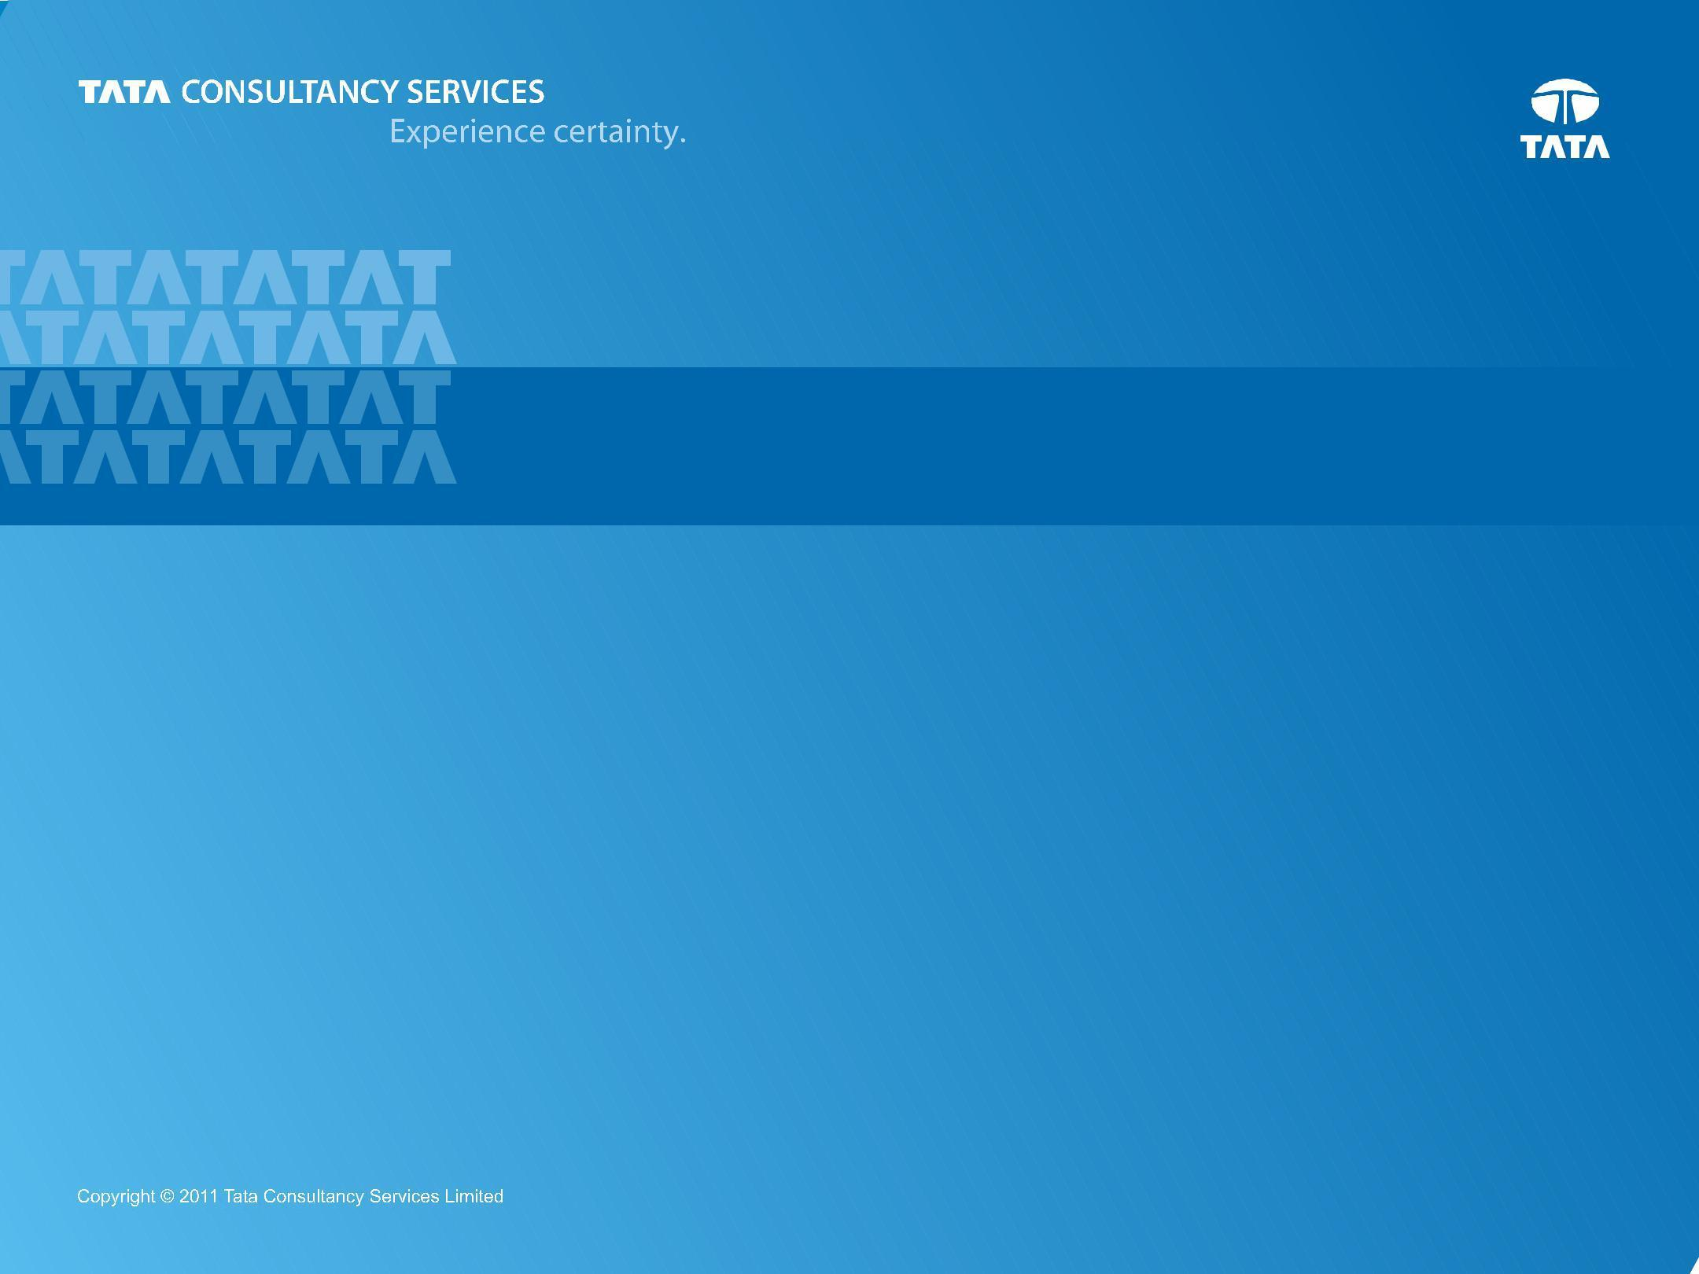

**THANK YOU**

**Prepared : October, 2014**

12